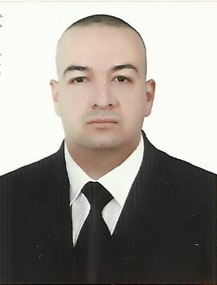
C.V
Name: Ali Sabah Abdull Hamied
Date & Place of Birth: 31-3-1983 Baghdad-Iraq
Marital Status: Single
Religion: Muslim
Nationality: Iraqi
Address: Zayuna-Baghdad-Iraq
Mobile: 00964-7801924676
E-Mail: assh83@yahoo.com

LANGUGES
Arabic: Mother Language's
English: Very good in Speaking-Writing –Reading

EDUCATION
2001-2005 College of Arts – University of Baghdad
Bachelor Degree in Archaeology.

JOBS
*I Worked In Dar Esalam Investment Bank (HSBC Iraq) from
2007 until 2016 as:
- Inward & outward remittances ( wire transfers ) Swift user
- Compliance Department
- Business Information Risk Officer ( BIRO)
- Deputy Head of Compliance
- Money Laundering Manager
- International Relationship Manager
- Relationships and Marketing Manager
*I worked in Abu Dhabi Islamic Bank –Iraq branch as :
Deputy Head of Compliance

Skills
- Very good at working on Microsoft office programs (Word, Excel ,outlook )
- Communications skills
- Hard working

COURSES and Training
- Attend workshop in HSBC Amman for information security
- Took training at Lebanon on SCDM system at HSBC Lebanon.
- Attend workshop on Dead Sea – Jordan to Operational procedures for the application of FATCA law at December 2012.
- Took training at Jordan on Banks system and be the one of responsible who gave the training to all Bank staff on Iraq.
- Took training on the World Check system on the Thomson Reuters Company Lebanon branch.
- Certificate from Iraq Private Banks League attended training course in Letters of credit.
- Attend training on Anti-Money Laundering, Terrorism Financing, Compliance and Risk Management on the CBI

